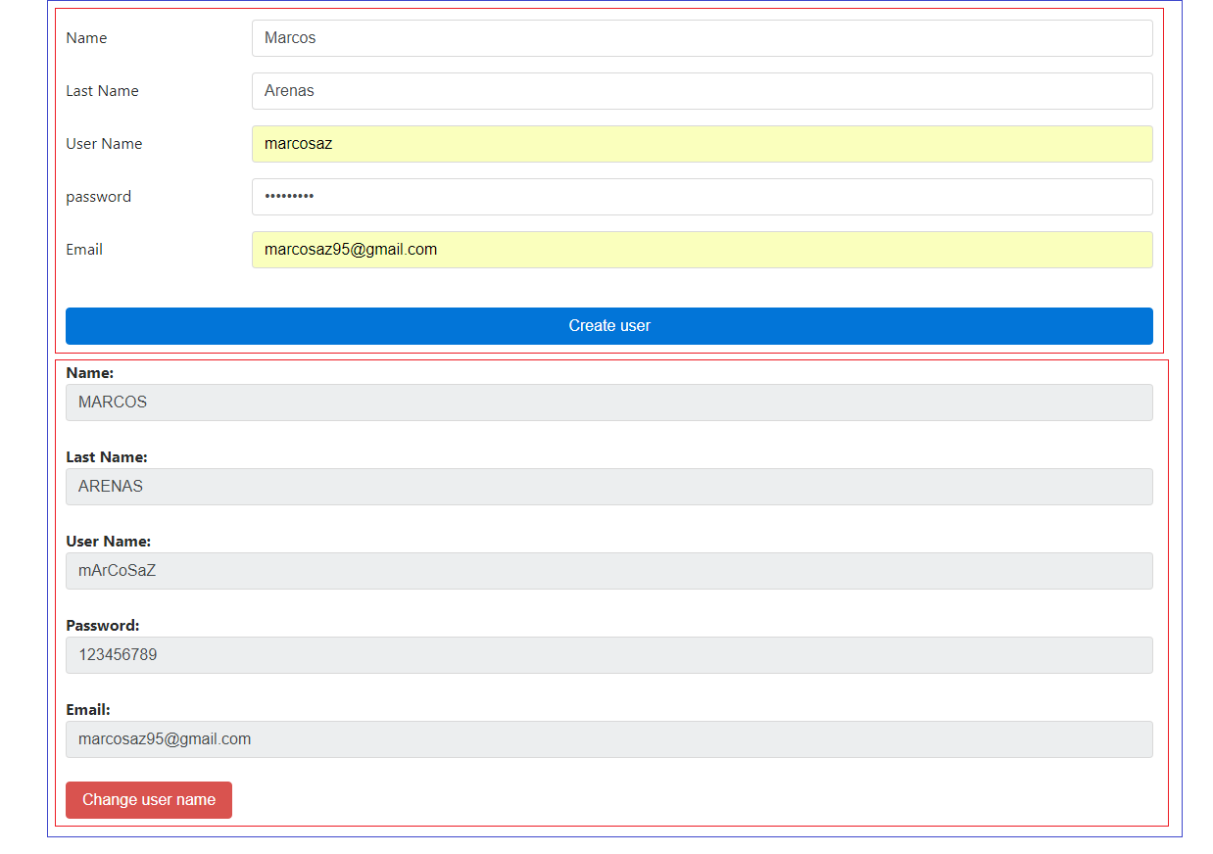

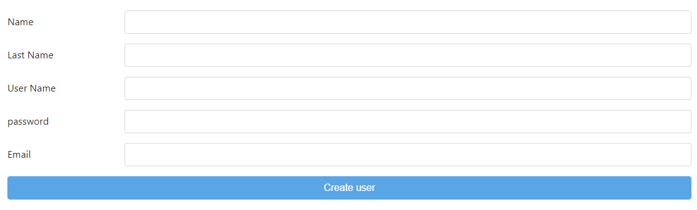

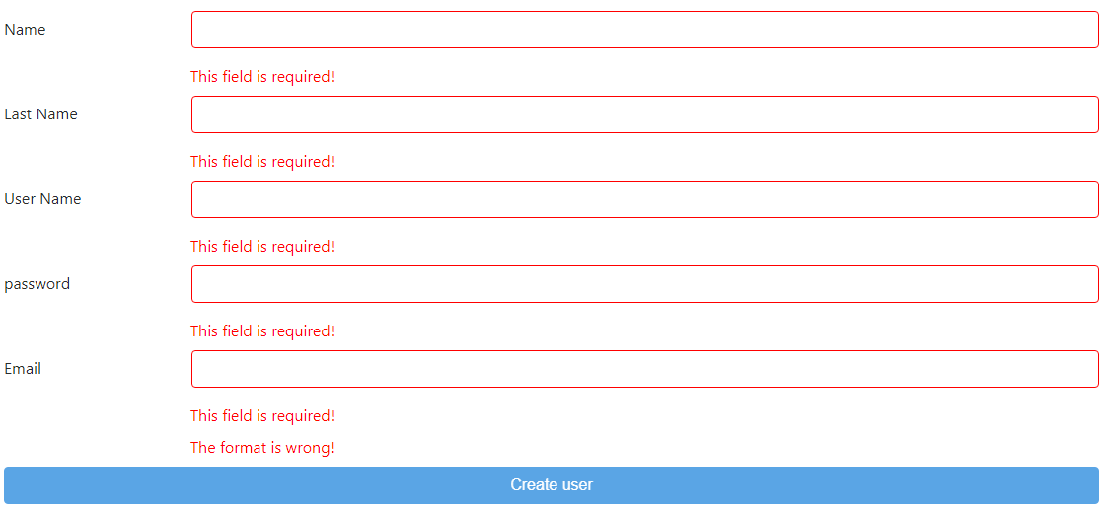

Instructions

* Create 3 components, the first one will be the parent component which contains the other two components, the second one will be a form and the third one will be the user component, this just display information depending of the user and it has a button to change the username.
* In the form component all of the fields are required, use ng-messages when the field was touched
* The field “Email” has another error, the format, you have to create a validator for this (You can use this Regex:

/^(([^<>()\[\][\\.,;:\s@"]+(\.[^<>()\[\]\\.,;:\s@"]+)\*)|(".+"))@((\[[0-9]{1,3}\.[0-9]{1,3}\.[0-9]{1,3}\.[0-9]{1,3}])|(([a-zA-Z\-0-9]+\.)+[a-zA-Z]{2,}))$/](file:///\\.,;:\s@%22%5d+(\.%5b%5e%3c%3e()\%5b\%5d\\.,;:\s@%22%5d+)*)|(%22.+%22))@((\%5b%5b0-9%5d%7b1,3%7d\.%5b0-9%5d%7b1,3%7d\.%5b0-9%5d%7b1,3%7d\.%5b0-9%5d%7b1,3%7d%5d)|((%5ba-zA-Z\-0-9%5d+\.)+%5ba-zA-Z%5d%7b2,%7d))$/)

* The button should be disabled until the form has been properly completed.
* After the user click on the button, you should fill the user component with the information.
* To display the name and the last name, use a parser for those fields to show it in uppercase.
* To display the username use a formatter to show one letter in uppercase and another in lowercase.
* When you click on the button to change user, you have to build a username with two forms:
  + First name letter + full last name
  + Full name + ‘.’ + full last name
  + The formatter for this field should change the uppercase and the lowercase depending of a random value, for example  
      
    Username: marcosaz  
    random value < 0.5 then the username will be MaRcOsAz  
    Other wise the username will be mArCoSaZ